The Redbelly Ford
By Orren K.Tench, Jr.
July, 2008

‘Fifty-one was a very good year
Korea aside, say what you may
For a farm boy just turned nine
Working tobacco, cattle, and hay

Horses and mules were still on the farm
But tractors were coming day-by-day
We had two of them by then
The big MM and the Farmall A

They came along after World War II
And did their jobs it’s fair to say
But they couldn’t hold a candle to
The 8N Ford painted red and gray

For twenty years the Fordson reigned
As the poor dirt farmer’s friend
But by ’30 it had run its course
And production came to an end

For nine long years there was no Ford
Then Henry saw the light
It came from Harry Ferguson
And Henry grabbed it tight

That Harry was a clever guy
He made the three-point hitch
And hydraulics so sublime
They made him very rich

Once I met a Coventry man
At the auto museum where
He told me that old Harry
Lived out his last days there

He had a bit of farmland
And a tractor so they say
He spent his time aboard the thing
Turning soil the livelong day

But I digress:
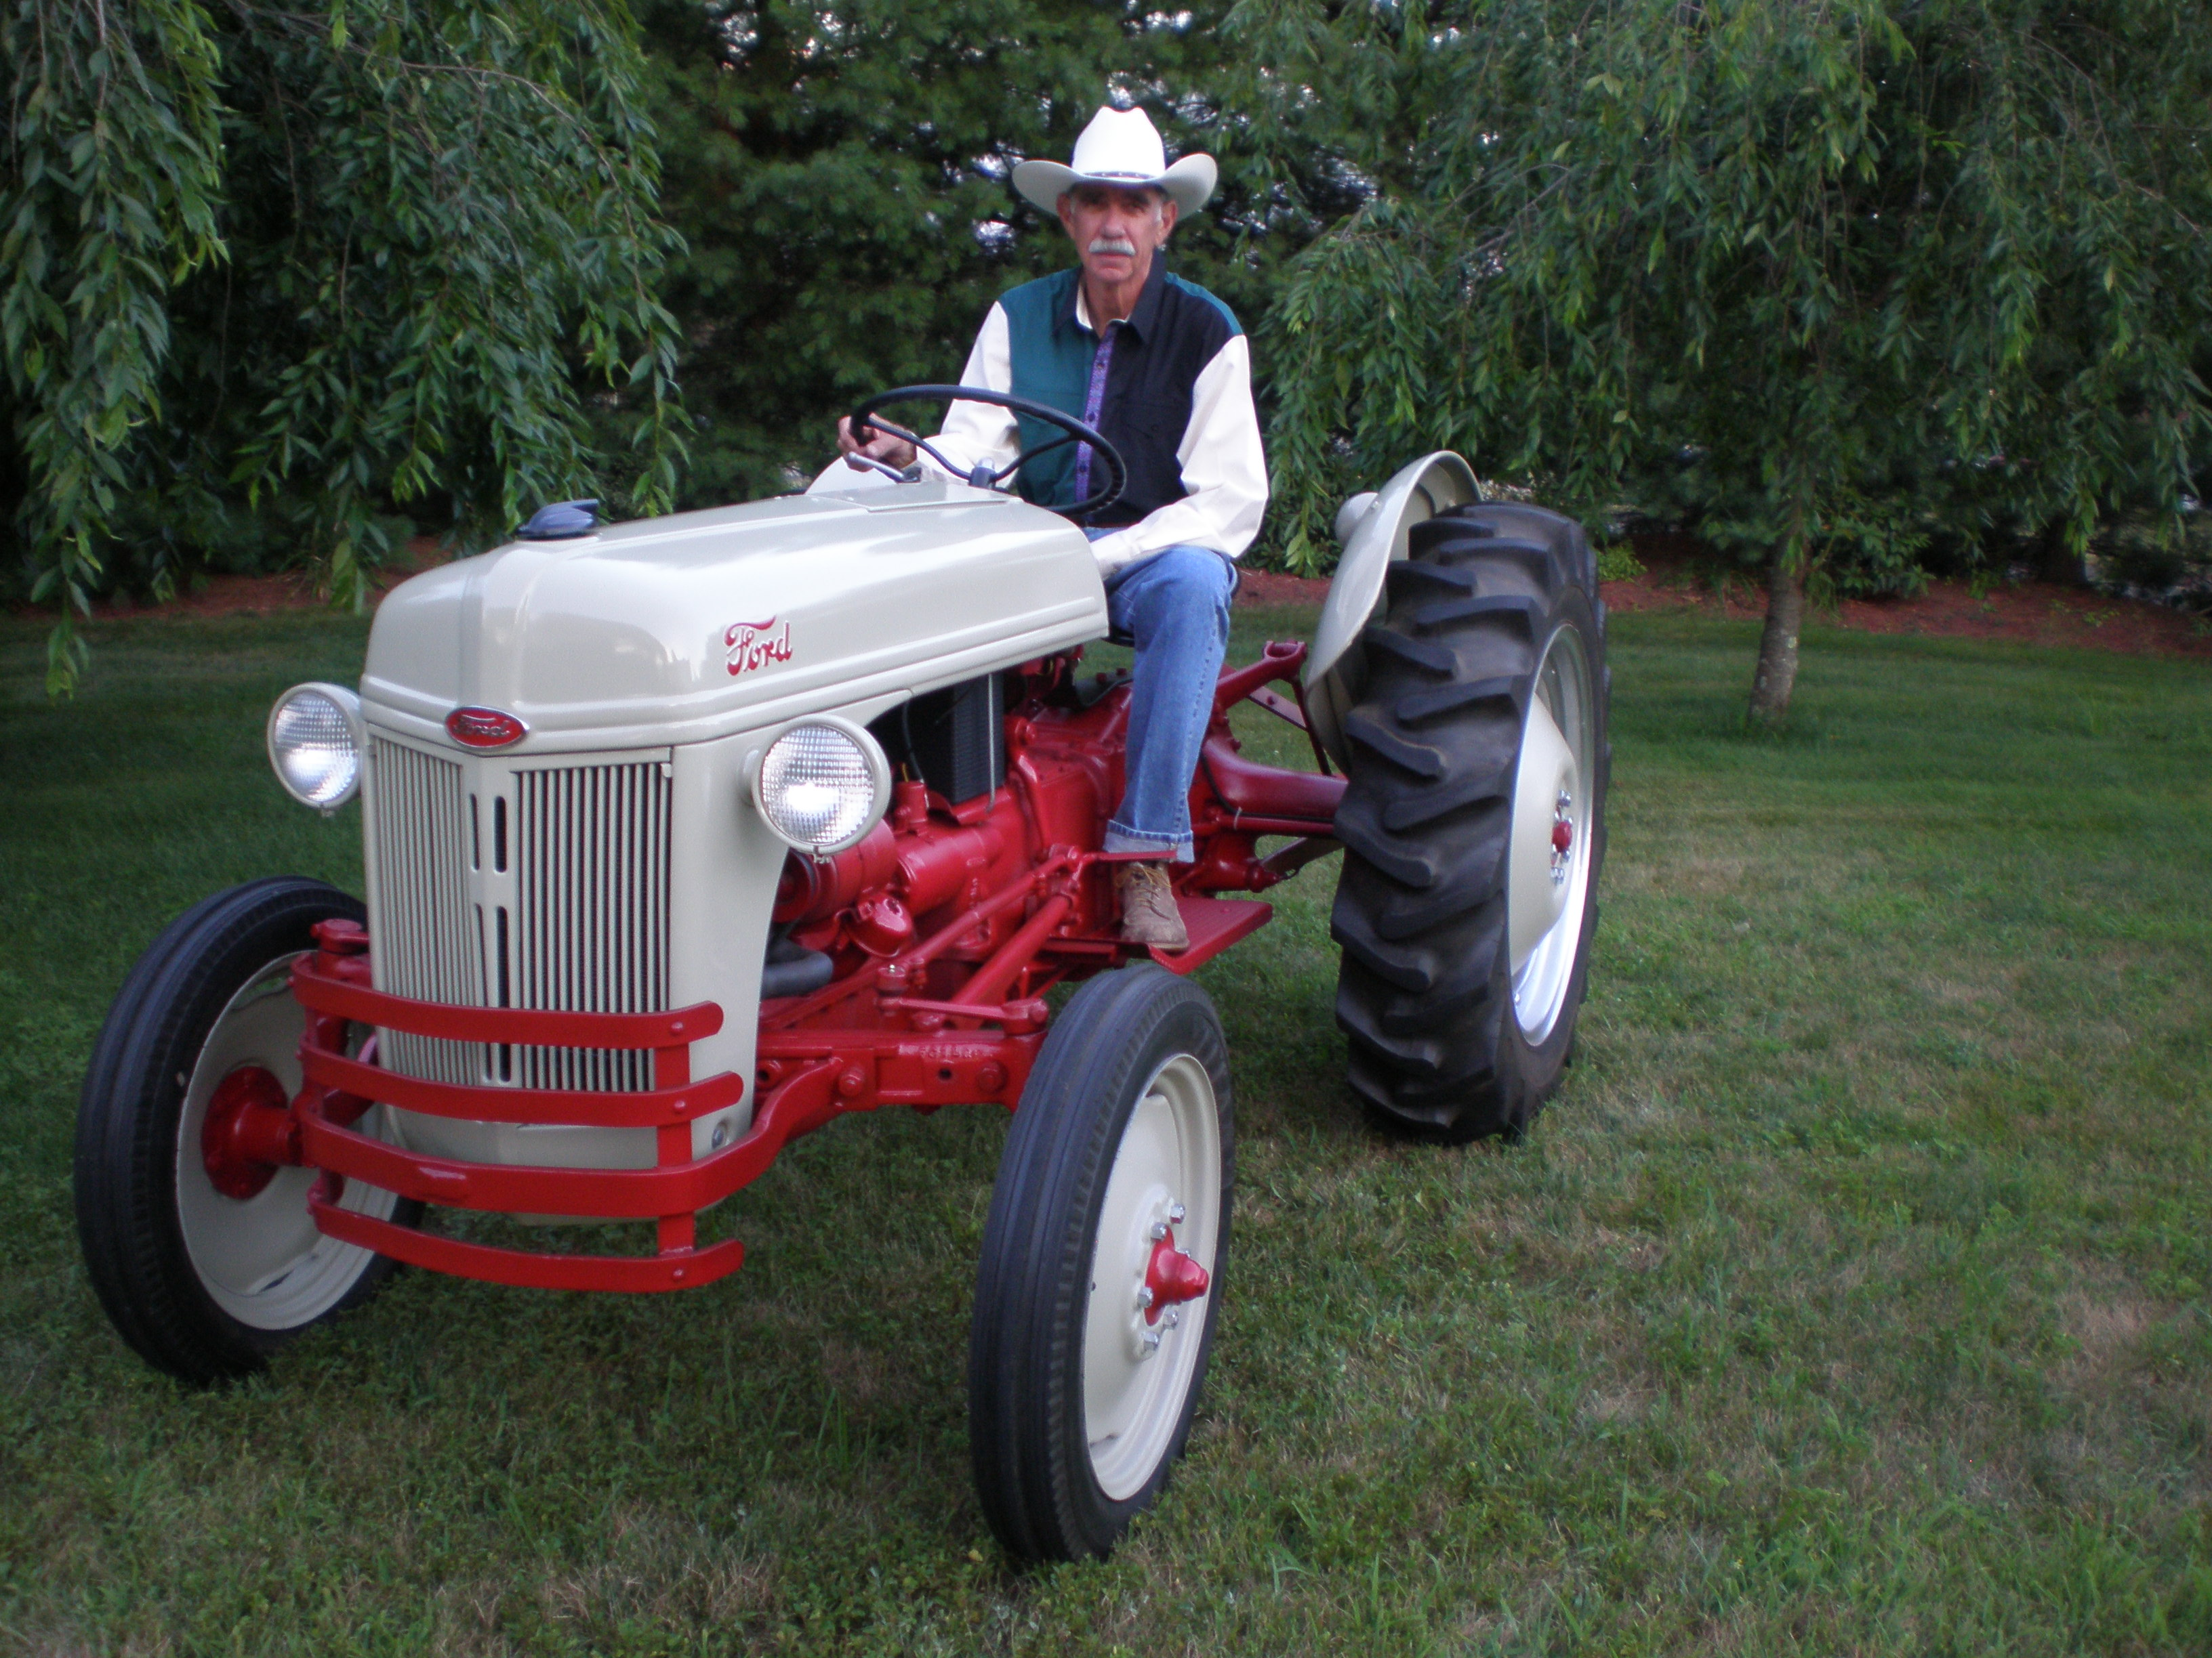

All hat and tractor, no land or cattle!

The 9N came in ‘39
The 2N followed in ‘42
The 8N came in ‘48
Therein lies the numbering clue

One half million would be built
By nineteen fifty-three
When the 8N was finally replaced
By the brand-new Jubilee

Now that young farm boy is growing old
He’s earned a life of ease
But after working hard for 60 years
He’s still down on his knees

There’s a Ford 8N back in his life
It takes up time and space
Restoration seems to take forever
Working at his slow pace

A good excuse to buy more tools
And always more to do
Untold hours of grit and grime
Until the job was through

And now at last the old 8N
Is back in youthful prime
Its shiny coat of red and gray
Tells Orren that it’s time

To finally find an answer to
The question undiminished
What you gonna do with her
Now that she’s finally finished

